***BENGAL INSTITUTE OF TECHNOLOGY***

***PROJECT TITLE :- ULTIMATE COMMUNICATOR***

***PRESENTED BY -***

***ACHINTA MITRA - IT – 2ND YEAR***

***APARAJITO GHOSH DASTIDAR - IT – 2ND YEAR***

***Ultimate Communicator***

* **Disability never seize us to communicate others**

**Abstract:-**

**The main ambition of structuring and making this android application is to provide the required and necessary supports to all disable person. This application basically consists of two platforms one that converts the text into the speech and another that converts the speech into the text. Let assume a situation the two disable person are traveling together one is duff-N-dumb and another is completely blind.**

**Now if that duff-N-dumb person are trying to say something to blind one by imitation, unfortunately blind one can’t see that , here the platform where text converts into speech will help. On the other hand if blind person wants to reply by uttering then duff-N-dumb one unable to listen that, here the platform where speech converts into text will help. As this application contains those two platforms, the front page will generate those two platforms simultaneously by two different card view section.**

**Hence this application is seems to be working smoothly upon the android level of 5.1.0 (Lollipop). Along with that in the platform where text converts into the speech one can set the pitching value and the audio capacity level according to the smooth way that the other person can listen.**

**Frequently Q & A:-**

* **What is Disability? It isn’t a character or behavior of any humans, it is just a disease obtained by hereditary or by any accidental scenario.**
* **Is disabled person completely disabled? No, if one disable person has one particular organ malfunctioning then his/her other organs are more intensive and accurate than the other person.**
* **What is the usefulness of this application? Actually this application is the medium of communication between two disabled people as they unable to communicate in normal way as the normal person do.**

**Program Flow (Flow Chart):-**

***Start Home Page***

***End of Speech To Text***

***End of Text To Speech***

***After Speak out the Input Text the content was destroyed by onDestroy()***

***Speak() method will convert the input into the String and prepare it***

***If status &result is SUCESS***

***Scanned By onInit() method***

***put it in ArrayList by getStringArrayListExtra***

***If result is OK & data isn’t Null***

***Scanned By getSpeech() method***

***Speech will visible on TextView Section***

***EXIT LAYOUT***

***Text To Speech Fragment***

***Speech To Text Fragment***

**Program Design (Diagram):-**

**Home Layout Section**

1. **Home Page of the Ultimate Communicator will contain two cardview section and one button. As example:- micCard, keyCard, exitBtn.**
2. **Now set specific id in each particular section and set onClickListener on each id(s).**

|  |  |
| --- | --- |
| Methods | Functionality |
| onCreate() | **Main method from which every application starts** |
| initID() | **Initialize all Ids with particular type** |
| onClick() | **Maintain the clickable functionality on three variable by their Ids** |

**Text To Speech Section**

1. **Taking variables on Text To Speech java segment as they are organized in particular way**
2. **etWrite as EditText, pitch_seek and speed_seek as two seekBars, speakBtn and returnBtn as two Buttons, tts as android.speech.tts.TextToSpeech.**
3. **Initialize all id(s) by a particular method.**
4. **Set onClickListner to speakBtn and returnBtn.**
5. **If LANG_MISSING_DATA and LANG_NOT_SUPPORTED is true then it will stop working.**

|  |  |
| --- | --- |
| Methods | Functionality |
| onCreate() | **Main method from which every application starts** |
| initID() | **Initialize all Ids with particular type** |
| speak() | **Generate the Text into String and prepare it according to pitch and speed value** |
| onDestroy() | **Destroy the previous line/word and ready for new acceptance.** |

**Speech To Text Section**

1. **Taking variables on Speech To Text java segment as they are organized in particular way**
2. **tvResult as TextView, ImageButton and returnBtn as two Buttons.**
3. **Initialize all id(s) by a particular method.**
4. **Set onClickListner to ImageButton and returnBtn.**
5. **ImageButton will record and store the sentence or the word by the users.**
6. **ACTION_RECOGNIZE_SPEECH will recognizing the language of the user.**
7. **EXTRA_LANG_MODEL and LANG_MODEL_FREE_FORM will receive the language type and source and redirecting it to the getDefault() method.**

|  |  |
| --- | --- |
| Methods | Functionality |
| onCreate() | **Main method from which every application starts** |
| initID() | **Initialize all Ids with particular type** |
| getSpeech() | **Get the language of voice from Google assistant either these are acceptable or not** |
| onActivityResult() | **Check if result is OK and data isn’t null then arrange it to the ArrayList and set it to the tvResult section** |

**Test Results (Snapshots):-**

**Here we are going to introduce some essence snapshots of our android application related project. Those are arranging sequentially one by one.**

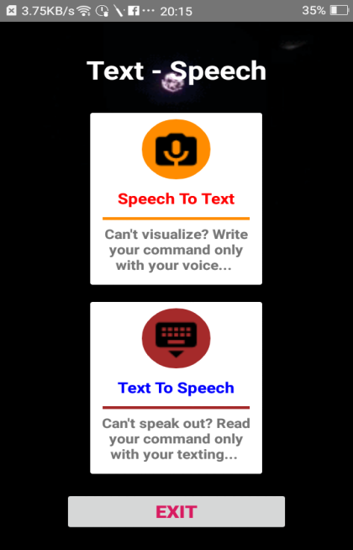

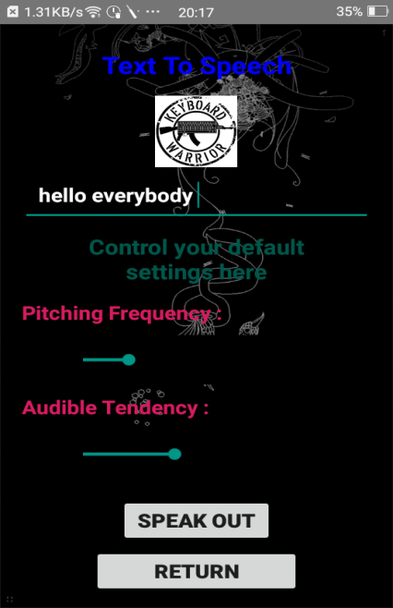 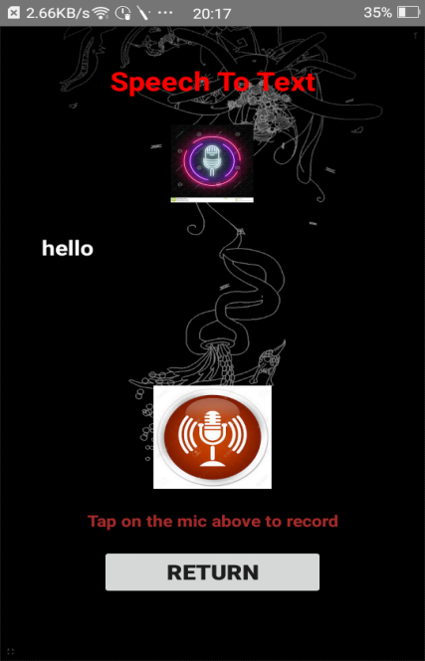

**Fig :- a) Home Page of Ultimate Communicator that directs two consecutive fragments – i. Speech to Text, ii. Text to Speech. b) Text to Speech template where text “hello everybody” will be audible when SPEAK OUT button clicked. c) Speech to Text template where word “hello” will be displayed after clicking mic button and saying the word.**

**Acknowledgement:-**

**Presentation inspiration and motivation have always played a key role in the success of any venture. We would like express our sincere thanks to Mr. Sivaji Panda, Principal, Bengal Institute of Technology.**

**Alongside we pay our deep sense of gratitude to Mr. Abhisek Bakshi and Mr. Sudipta Bhattacharya to encourage us to the highest peek and to provide us the necessary opportunity to prepare and complete our project as well they also inspecting our project (android application) and correcting necessary areas with intense patience.**

**We are immensely obliged to our fellow friends for their elevation inspiration, encouraging guidance and kind supervision in the complete of my project.**

**We also pay our deep sense of gratitude to our guide Mrs. Tripti Basu, whose valuable guidance and the kind supervision given to me throughout the course which shaped the present work as its show.**